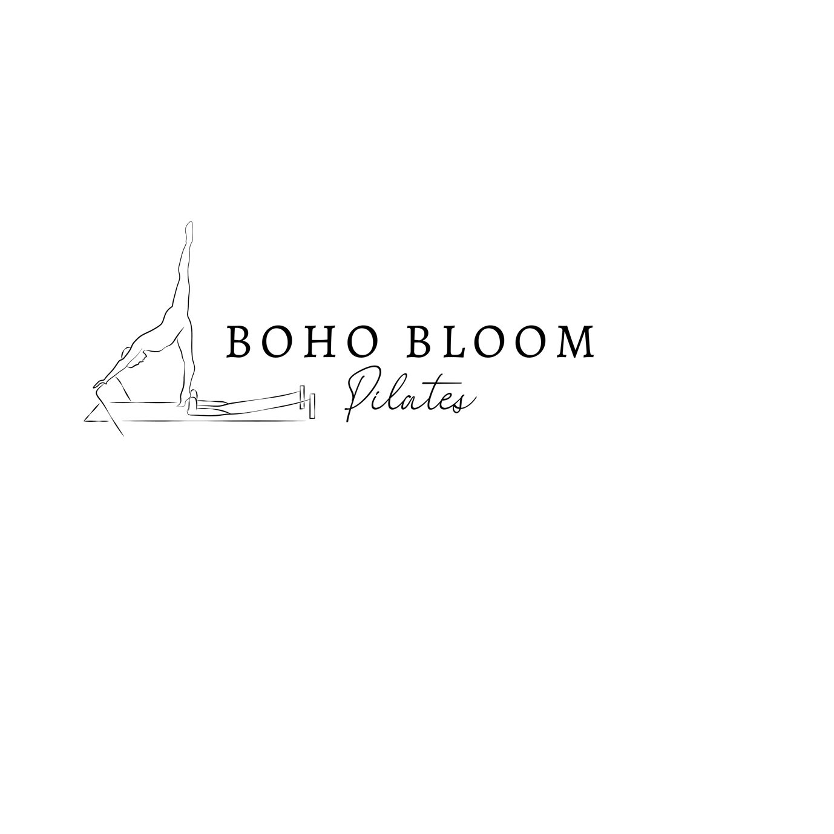

TERMS AND CONDITIONS

The terms and conditions are as follows:

- All sales are final.
1A. You confirm that you have obtained your medical practitioner's express approval and clearance to participate in the session;
2. You confirm that at the time of participating in the session you are not pregnant or post natal without a doctor’s clearance to participate in Pilates training;
3. You confirm that at the time of participating in the session you are not unwell; 4. You confirm that at the time of participating in the session you are not suffering from any form of mental and/or physical injury;
5. Should you not be able to give all of the confirmations at paragraphs 1 – 4, above, you must not participate in the session;
6. You accept and acknowledge that Amy Bird, whose rights are reserved in full, shall not be liable for any injury, damage and/or loss however caused that might arise in connection with your participation in a session: - if you participate having not been in a position to give the confirmations at paragraphs 1 - 4, above;- if you participate against a medical practitioner's instruction and/or guidance; - if you fail to comply with any instruction given during the session, in particular, but without limitation, in relation to safety and/or technique; and/or - if any injury, damage and/or loss is caused by one or more class participants.
7. Should a provision of these terms and conditions become invalid or unenforceable, that shall not affect the validity or enforceability of any other provision of these terms and conditions;
8. Any dispute or matter in relation to these terms and conditions or otherwise arising from your participation in a session are subject to the laws of Powys, Wales;
9. Any dispute or matter in relation to these terms and conditions or otherwise arising from your participation in a session are subject to the exclusive jurisdiction of the courts of Powys, Wales; and
10. Nothing in these terms and conditions shall constitute a waiver of Amy Bird’s rights.
11.Participants between the ages of 13 to 18 years must have written consent from either a parent or a guardian.
Your participation in a session shall constitute your acknowledgement and irrevocable acceptance of these terms and conditions.

